## SOFTWARE QUALITY ASSURANCE MANAGEMENT

## NAME:S.Logitha

## REG NO:192121138

**10.USING RAPTOR – COMPUTE QUOTIENT AND REMAINDER**

**FLOWCHART**

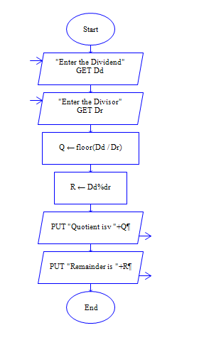

**OUTPUT**

DIVIDEND 9 AND DIVISOR 4

